Updated Predictive Talent Assessment

Partner written communications for their clients
Earlier this year, Chally launched a new website and brought us the first-to-market Predictive Engagement Assessment. This month, Chally released an updated version of the Predictive Talent Assessment!
Chally remains committed to leveraging the latest science to bring you state-of-the-art assessments. Over the last year, their team of Industrial-Organizational psychologists performed a thorough review of their 138 competencies and benchmark profiles. Their research confirmed that their competencies and profiles remain accurate and represent jobs in the market today. At the same time, they heard your feedback and have been working tirelessly over the past year to bring you an updated assessment with an improved user experience.
What is being updated?
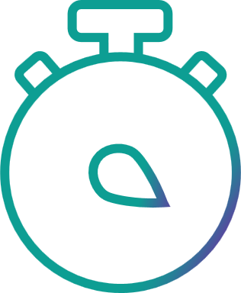 | Length: Chally cut down the time of the powerful assessment by 50% without sacrificing the validity.
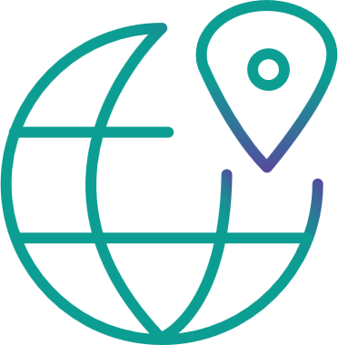 | Questions: Chally simplified and streamlined the assessment questions to further enhance its applicability across the globe.
What is staying the same?
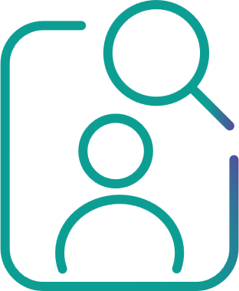 | Reliability: Chally reconfirmed its content is up-to-date and valid for predicting success in today’s environment.
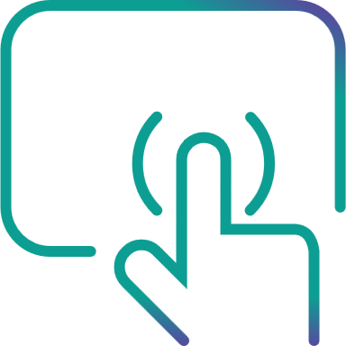 | Intuitive Design: The assessment and the easy-to-use Chally Platform look and feel exactly the same as before.

Access: The release will not impact any existing projects and you can choose which version meets your current needs.
To learn more contact us with a time that works best for you.

Partner social media communications for their clients
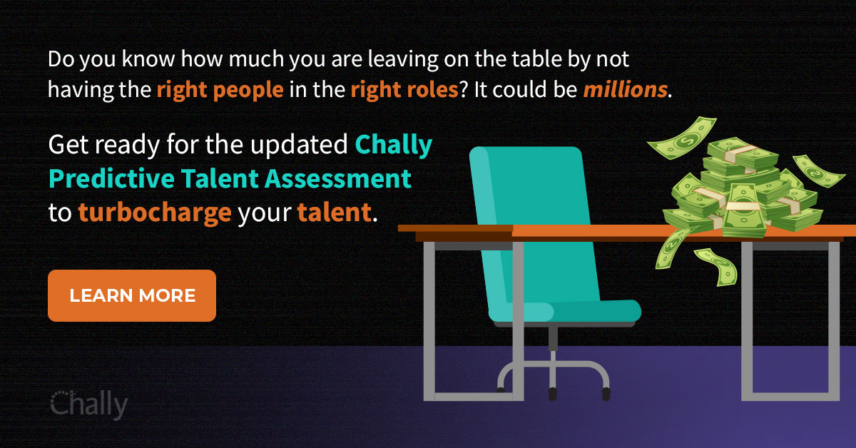
You can co-brand and add your logo.
Your “Learn More” can be directed to your contact website page.
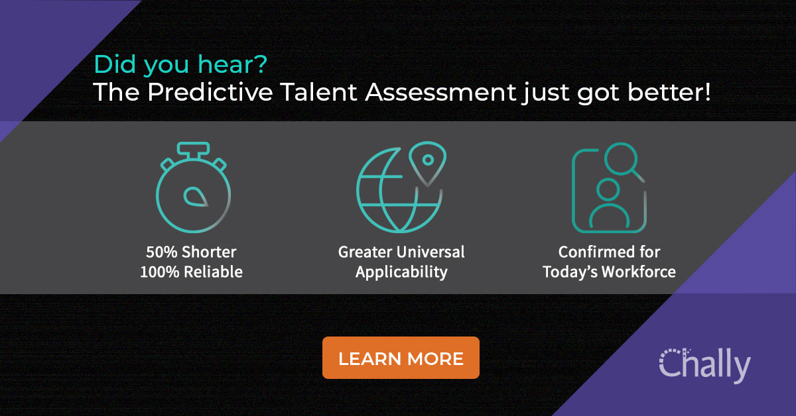
You can co-brand and add your logo.
Your “Learn More” can be directed to our updated Predictive Talent Assessment pdf file.

